Frequency Distribution

A Frequency Distribution is a grouping of data into mutually exclusive categories showing the number of observations in each class.

Class limit: The class limits are the lowest and the highest values that can be included in the class.

Class interval: The class interval is obtained by subtracting the upper limit of a class from the lower limit of the next class. The class intervals should be equal. It is denoted here by i

Class Frequency: The number of observations in each class. It is denoted here by f.

Class Midpoint: A point that divides a class into two equal parts. This is the average of the upper and lower class limits.

Construction of frequency distribution:

Example:
Mr. Rahman is a professor of X University. He wishes prepare to a report showing the number of hours per week students spend studying. He selects a random sample of 30 students and determines the number of hours each student studied last week.

15.0, 23.7, 19.7, 15.4, 18.3, 23.0, 14.2, 20.8, 13.5, 20.7, 17.4, 18.6, 12.9, 20.3, 13.7, 21.4, 18.3, 29.8, 17.1, 18.9, 10.3, 26.1, 15.7, 14.0, 17.8, 33.8, 23.2, 12.9, 27.1, 16.6.

Organize the data into a frequency distribution

Step One: First arrange the data in ascending order. Then we get the data as:

10.3, 12.9, 12.9, 13.5, 13.7, 14, 14.2, 15, 15.4, 15.7, 16.6,17.1, 17.4, 17.8, 18.3, 18.3, 18.6, 18.9, 19.7, 20.3, 20.7, 20.8, 21.4, 23, 23.2, 23.7, 26.1, 27.1, 29.8, 33.8,.

Step Two: Decide on the number of classes using the formula
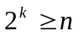

Where k=number of classes
n=number of observations
- There are 30 observations so n=30.

- Two raised to the fifth power is 32.

- Therefore, we should have at least 5 classes, i.e., k=5.

Step Three: determine the class interval or width using the formula

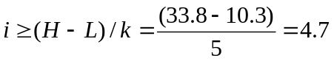
Round up for an interval of 5 hours.

Set the lower limit of the first class at 7.5 hours, giving a total of 6 classes.

Step Four: Set the individual class limits and

Steps Five and Six: Tally and count the number of items in each class.

Hours studying | Tally | Frequency, f
7.5 up to 12.5 | I | 1
12.5 up to 17.5 | IIII IIII II | 12
17.5 up to 22.5 | IIII IIII | 10
22.5 up to 27.5 | IIII | 5
27.5 up to 32.5 | I | 1
32.5 up to 37.5 | I | 1

Class Midpoint: find the midpoint of each interval, use the following formula:
Upper limit + lower limit
2

Hours studying | Midpoint | f
7.5 up to 12.5 | (12.5+7.5)/2 =10.0 | 1
12.5 up to 17.5 | (17.5+12.5)/2=15.0 | 12
17.5 up to 22.5 | (22.5+17.5)/2=20.0 | 10
22.5 up to 27.5 | (27.5+22.5)/2=25.0 | 5
27.5 up to 32.5 | (32.5+27.5)/2=30.0 | 1
32.5 up to 37.5 | (37.5+32.5)/2=35.0 | 1

A Relative Frequency Distribution shows the percent of observations in each class.

Hours | f | Relative Frequency
7.5 up to 12.5 | 1 | 1/30=.0333
12.5 up to 17.5 | 12 | 12/30=.400
17.5 up to 22.5 | 10 | 10/30=.333
22.5 up to 27.5 | 5 | 5/30=.1667
27.5 up to 32.5 | 1 | 1/30=.0333
32.5 up to 37.5 | 1 | 1/30=.0333
TOTAL | 30 | 30/30=1

Cumulative Frequency Distribution
A Cumulative Frequency Distribution is used to determine how many or what proportion of the data values are below or above a certain value.

Cumulative Frequency Table for Hours Spent Studying

Hours  Studying | Upper Limit | f | Cumulative Frequency
7.5 up to 12.5 | 12.5 | 1 | 1
12.5 up to 17.5 | 17.5 | 12 | 13 (1+12)
17.5 up to 22.5 | 22.5 | 10 | 23 (13+10)
22.5 up to 27.5 | 27.5 | 5 | 28 (23+5)
27.5 up to 32.5 | 32.5 | 1 | 29 (28+1)
32.5 up to 37.5 | 37.5 | 1 | 30 (29+1)

For Continuous data or quantitative variables:
The three commonly used graphic forms are Histograms, Frequency Polygons, and a Cumulative Frequency Curve.

Histogram:
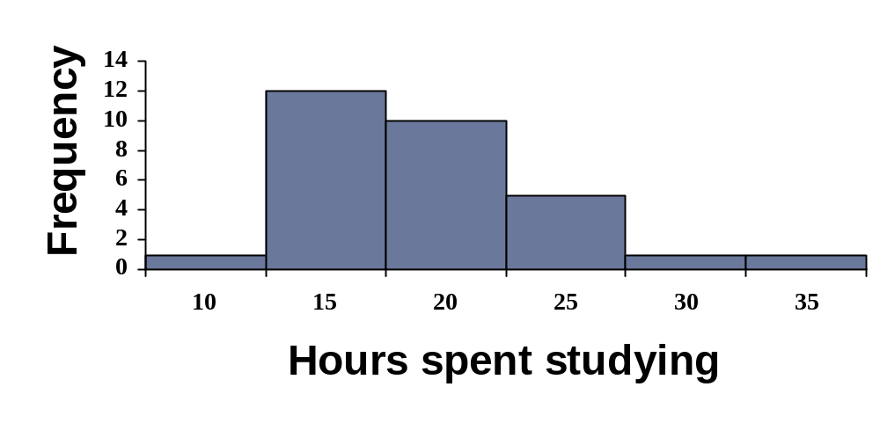A Histogram is a graph in which the class midpoints or limits are marked on the horizontal axis and the class frequencies on the vertical axis. The class frequencies are represented by the heights of the bars and the bars are drawn adjacent to each other.

Frequency Polygon:
A Frequency Polygon consists of line segments connecting the points formed by the class midpoint and the class frequency.

Frequency Polygon for Hours Spent Studying

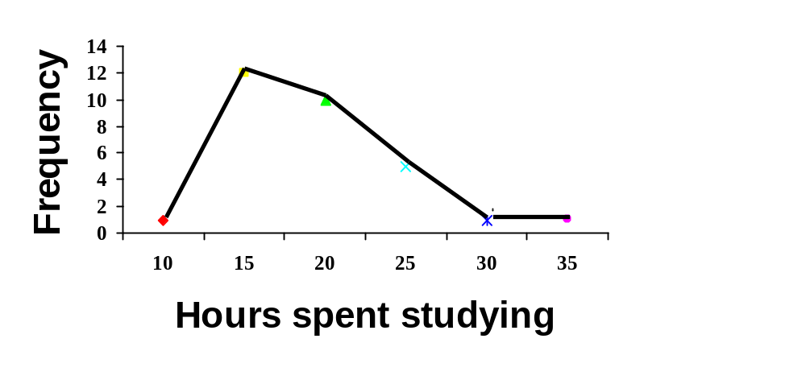

Cumulative Frequency Curve or Ogive: A Cumulative Frequency curve is used to determine how many or what proportion of the data values are below or above a certain value.
There are 2 methods of constructing ogive
- The less than method
- The more than method
Less than method: In less than method, we start with the upper limits of the classes and go on adding the frequencies. When the frequencies are plotted, we get a rising curve.
More than method: In more than method, we start with the lower limits of the classes and go on adding the frequencies. When the frequencies are plotted, we get a declining curve.
- Example :( Less then Method)
To create a cumulative frequency curve, scale the upper limit of each class along the X-axis and the corresponding cumulative frequencies along the Y-axis.

Cumulative Frequency Table for Hours Spent Studying

Hours  Studying | Upper Limit | f | Cumulative Frequency
7.5 up to 12.5 | 12.5 | 1 | 1
12.5 up to 17.5 | 17.5 | 12 | 13 (1+12)
17.5 up to 22.5 | 22.5 | 10 | 23 (13+10)
22.5 up to 27.5 | 27.5 | 5 | 28 (23+5)
27.5 up to 32.5 | 32.5 | 1 | 29 (28+1)
32.5 up to 37.5 | 37.5 | 1 | 30 (29+1)

Cumulative Frequency curve for Hours Studying Cumulative Frequency Distribution for Hours Studying

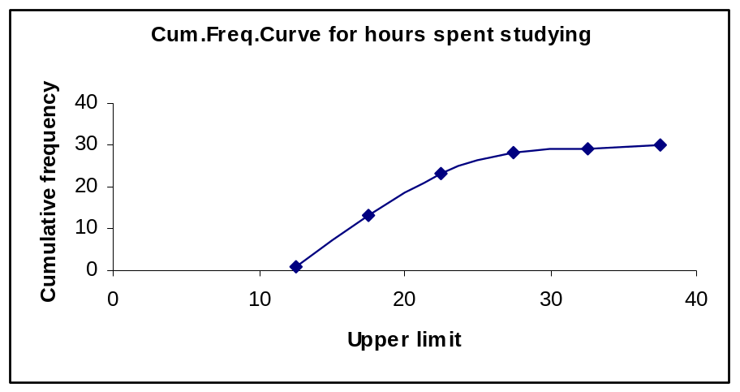

Graphs for time series data:
- Line graphs are typically used to show the change or trend in a variable over time.

Year | Males | Females
1992 | 30.5 | 32.9
1993 | 30.8 | 33.2
1994 | 31.1 | 33.5
1995 | 31.4 | 33.8
1996 | 31.6 | 34.0
1997 | 31.9 | 34.3
1998 | 32.2 | 34.6
1999 | 32.5 | 34.9
2000 | 32.8 | 35.2
2001 | 33.2 | 35.5
2002 | 33.5 | 35.8

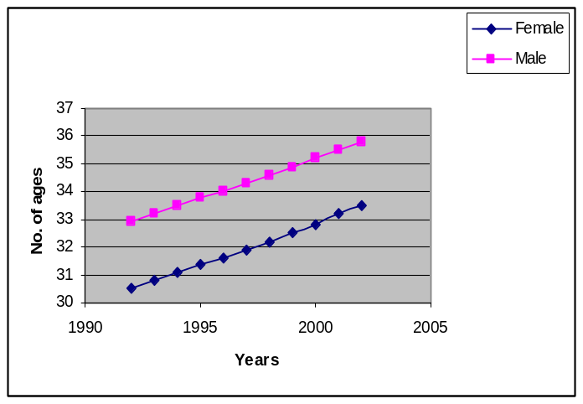
Bar Chart:
In bar chart the classes are reported on the horizontal axis and the class frequencies on the vertical axis.
Example: Construct a bar chart for the number of unemployed per 100,000 populations for selected cities during 2001

City | No. of unemployed /100000
Atlanta, GA | 7300
Boston, MA | 5400
Chicago, IL | 6700
Los Angeles, CA | 8900
New York, NY | 8200
Washington, D.C. | 8900

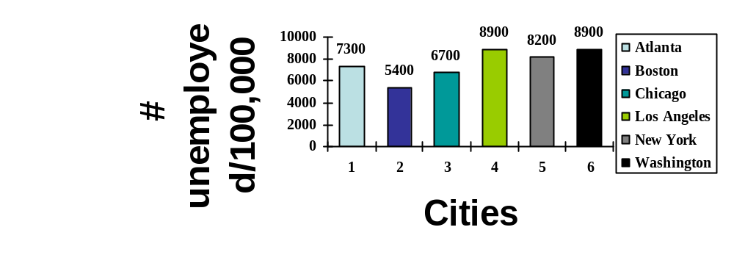

A Pie Chart is useful for displaying a relative frequency distribution. A circle is divided proportionally to the relative frequency and portions of the circle are allocated for the different groups.

A sample of 200 runners was asked to indicate their favorite type of running shoe. Draw a pie chart based on the following information.

Type of shoe | # of runners | % of total
Nike | 92 | 46.0
Adidas | 49 | 24.5
Reebok | 37 | 18.5
Asics | 13 | 6.5
Other | 9 | 4.5

Pie Chart for Running Shoes

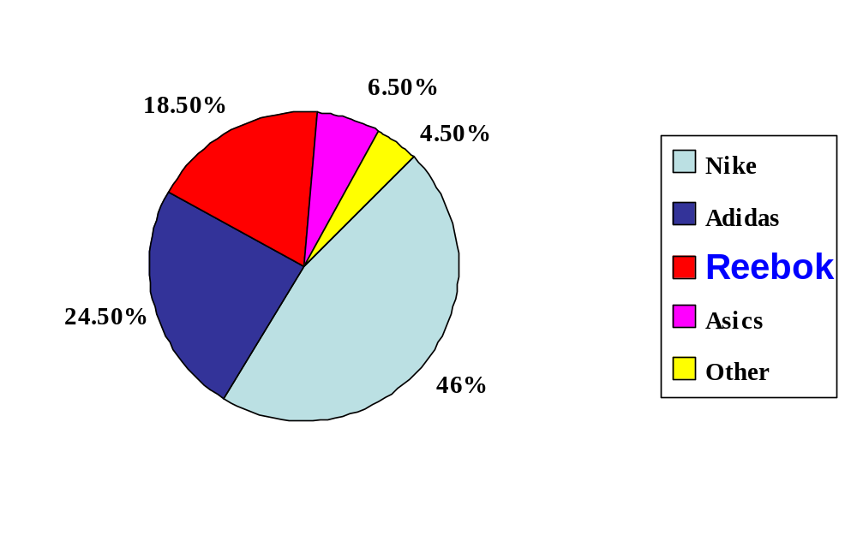

Use of Diagrams:

Uses of bar chart:
- Present few data over a nominal (e.g. countries, testing conditions ...) i.e. it useful only discrete or qualitative data.
- useful for comparisons of data
- Can not use in large sets of data or continuous data.

Uses of histogram:
- Visually strong
- Histogram is 2 dimensional i.e. in histogram as well as width are important.
- useful for larger sets of data points, typically used for frequency distributions
- Use only continuous data sets.

Uses Pie Chart:
- convey approximate proportional relationships (relative amounts) at a point in time
- compare part of a whole at a given point in time
- emphasize a small proportion of parts

Uses of Cumulative frequency curve:
- To determine as well as portray the number or proportion of cases above or below a given value
- To compare 2 or more frequency distributions.
Uses of line graph:
- For analyzing the changes at different points of time.

Difference between Histogram and bar diagram:
- Histogram is use for continuous data and bar diagram is use for discrete data.
- Histogram is 2 dimensional i.e. in histogram as well as width are important. But bar diagram is 1 dimensional i.e. it is only the length of the bar that matters and not the width.

